Depth First Search (DFS)
Aim
To implement the Depth First Search (DFS) algorithm for graph traversal.
Objectives
- To understand depth-wise traversal.
- To visit all graph nodes.
- To implement DFS using recursion.
- To explore each branch completely before backtracking.
Algorithm
- Start.
- Create a graph.
- Select the starting node.
- Mark the node as visited.
- Visit the node.
- Recursively visit all unvisited adjacent nodes.
- Repeat until all nodes are visited.
- Stop.

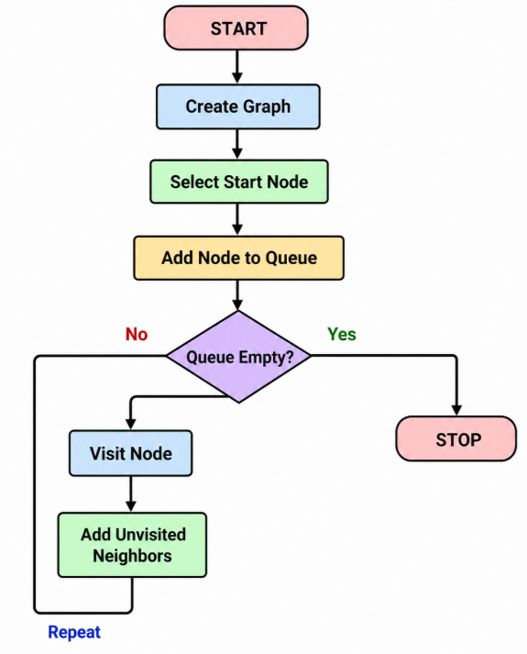

PROGRAM
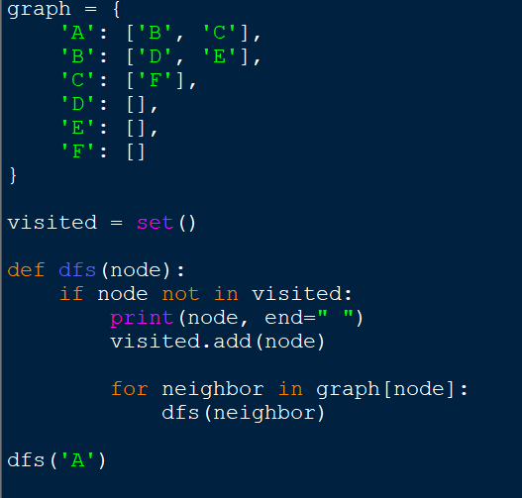

OUTPUT

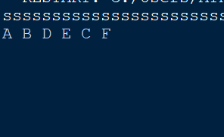

Result
The DFS algorithm was successfully implemented and traversed the graph using depth-first traversal.

